**ReplicaSet:**

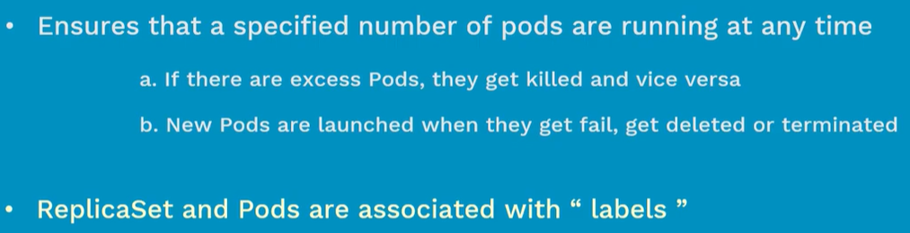

**Replicaset vs replication controller:**

* Replicaset is a next generation on replication controller
* They both are same except the apiversion and selector type
* Replicaset supports set based selectors and replication controller supports equality-based selectors
* We manage pods using the services, replication controllers etc.
* Labels are just key value pairs that we give to pods. These are just like tags and it will help to us manage the pods together

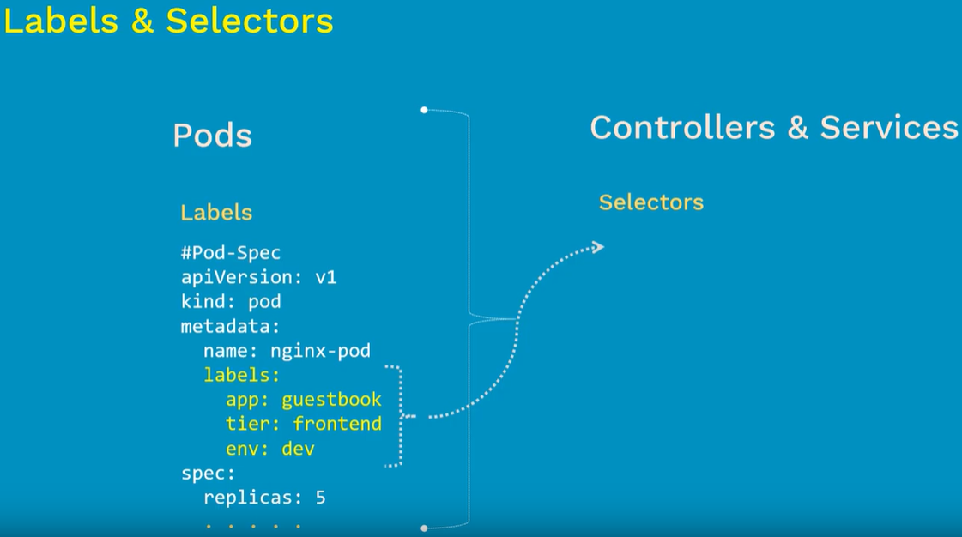

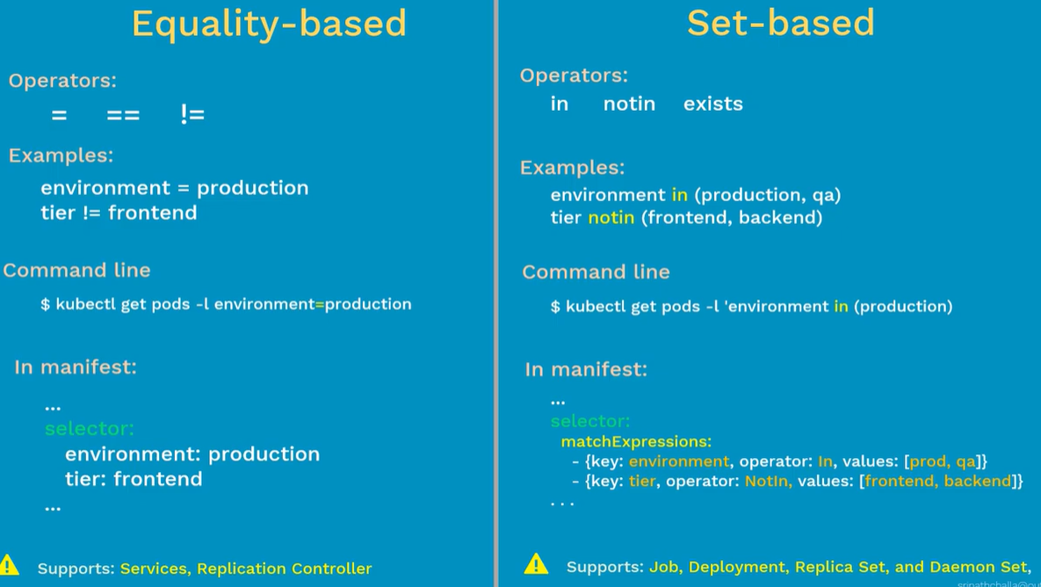

* Equality based selectors are easy to use but less powerful than set based
* Set based are a bit difficult but it is very powerful
* Even in selector section of set based, we need to add the lables with 3 options such as “key”, “operator” and “values” as above.

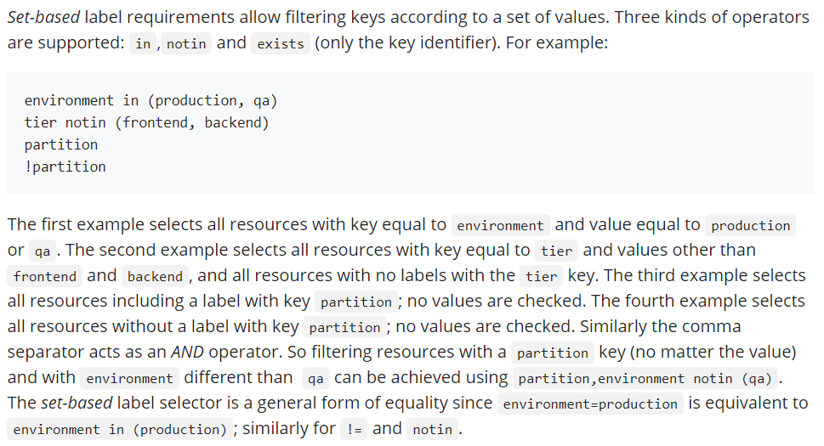

* We can not have multiple values for a single key

**Match labels vs without match labels:**

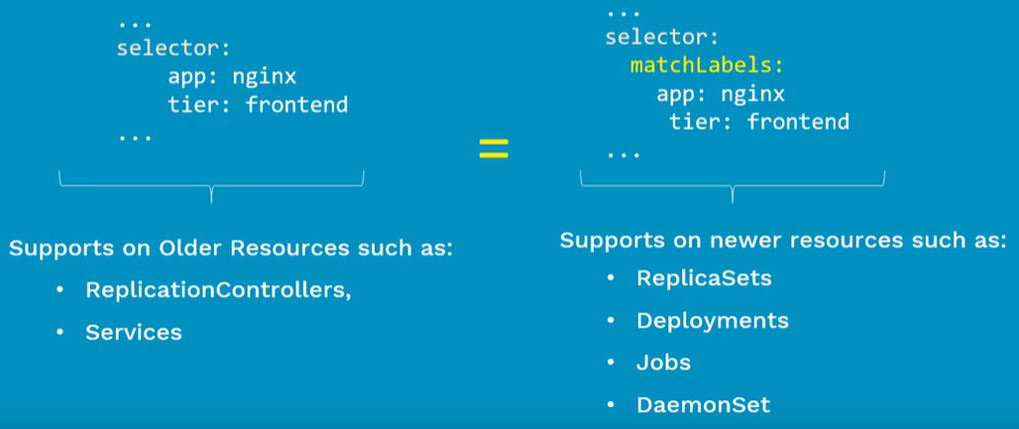

* We don’t use “matchLabels” for older resources like replication controllers and services
* We use it for new resources such as replicasets, deployments, jobs and daemonset

**Replicaset yaml file:**

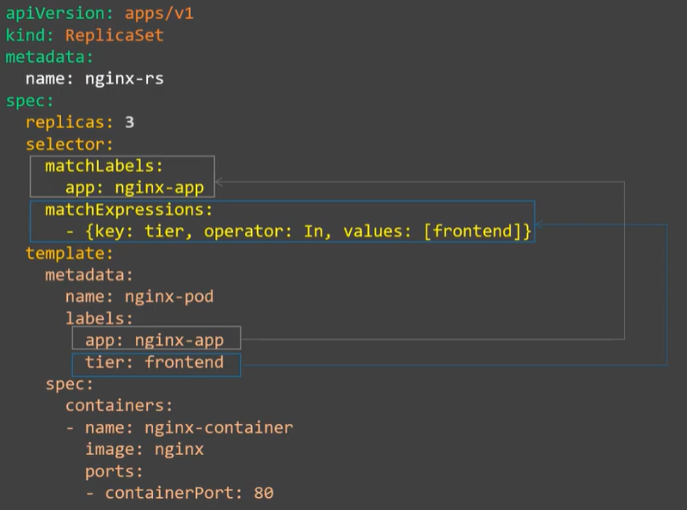

* If we have one label to select, then we can go for “matchLabels” only. But we need to use “matchExpressions” if there are more as above
* Rest all it works the same way as replication controller does

**Examples:**

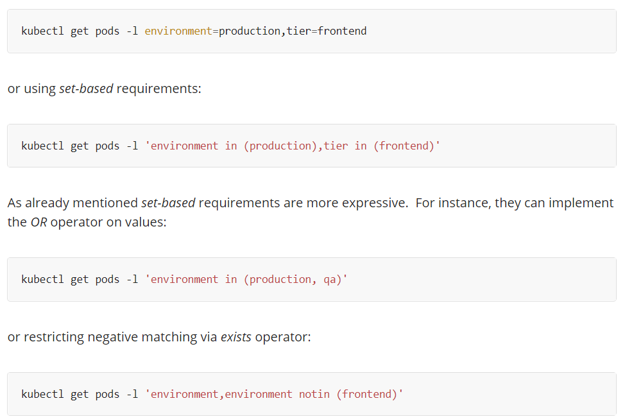

We can use the below command if we want to filter key with any one of the value.

* **Kubectl get pods -l ‘environment in (production, qa)’**

We can filter all the other pods with the key which doesn’t contain the given values as below.

* **Kubectl get pods -l ‘tier notin (frontend, backend)’**

We can filter the pods if the key exists. Doesn’t matter about the value.

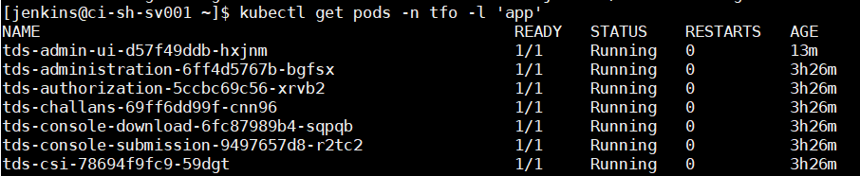

Also, we can filter the pods which doesn’t contain the given key as below.

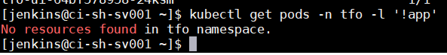

**Create & display:**

* **Kubectl get pods –show-labels**

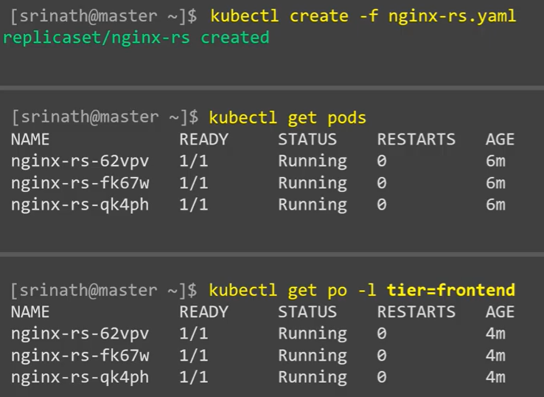

**Describe:**

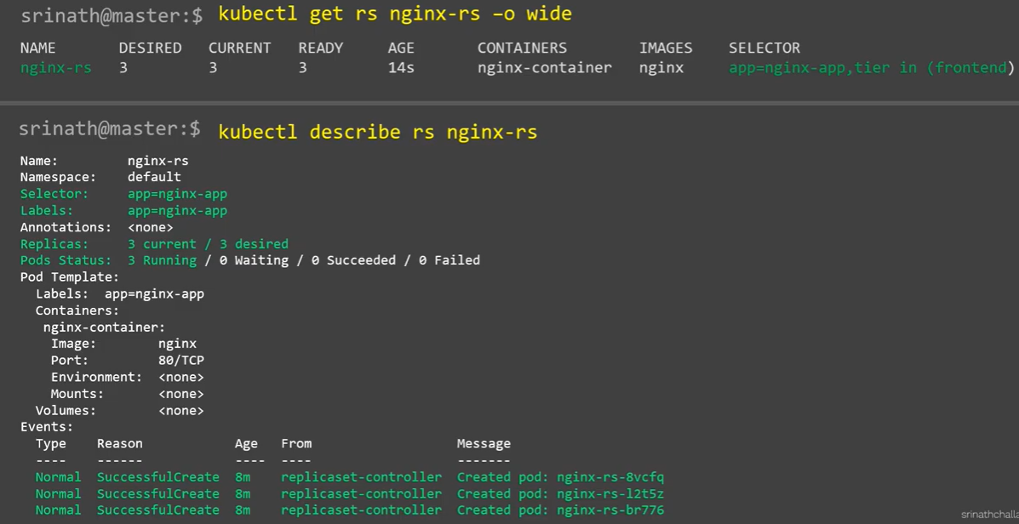

**Scheduling:**

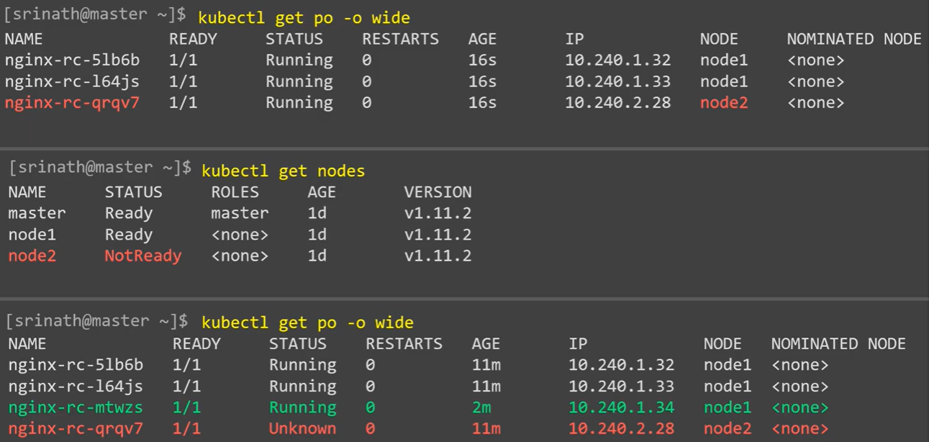

**Scaling up:**

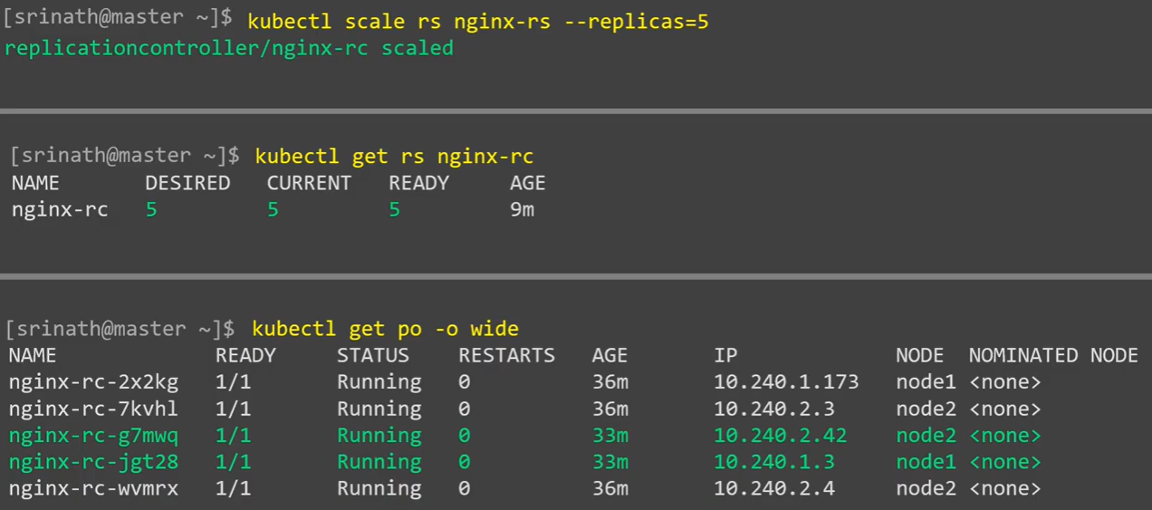

**Scaling down:**

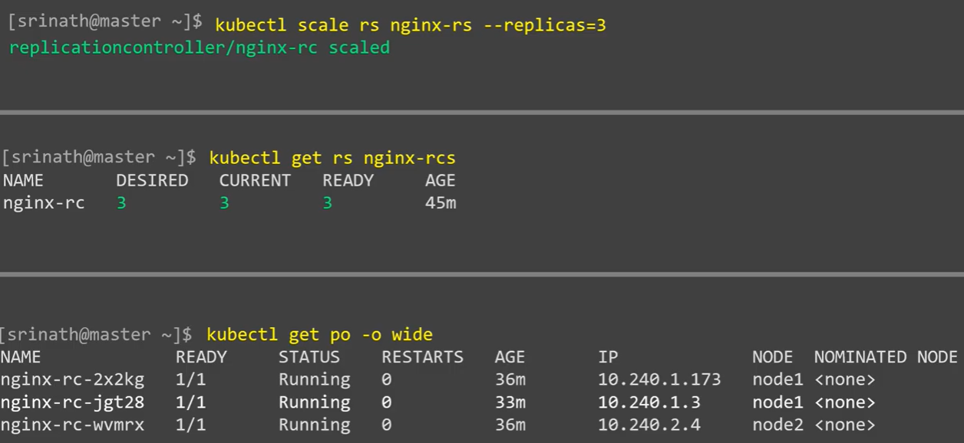

**Delete:**

